**Welcome Back Turtle Assignment:**

1. 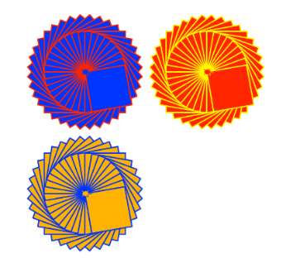Create a Python Turtle program to do the following:
2. Draw an interesting shape using multiple basic shapes   
   and pen colors.
3. Use the **goto(x,y)** function to move the starting point for the shape   
   to a different location on the output window.
4. Use a **counted loop** to draw multiple copies of your shape at different   
   positions on the output window.
5. Use the **input()** function to ask for a number of times to repeat the shape. Use this number to control the repeat of the counted loop.
6. Extension. Check the repeat number input to make sure it is a valid number and that it is between the range of 1 to 6 repeats.
7. Use print screen to copy and paste an image of your program output below.

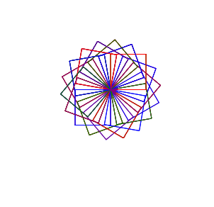

1. Provide a listing of your Python program below.
2. import turtle
3. turtle.speed (50)
4. turtle.color ('White')
5. turtle.goto (20,30)
6. shapeCount = input("Number of shapes to draw: ")
7. count_int = int(shapeCount)
8. if count_int > 1:
9. for i in range(count_int):
10. turtle.color ('Purple')
11. turtle.left(20)
12. turtle.forward(50)
13. turtle.left(90)
14. turtle.forward(50)
15. turtle.left(90)
16. turtle.forward(50)
17. turtle.left(90)
18. turtle.forward(50)
19. turtle.left(90)
20. turtle.color ('Red')
21. turtle.left(20)
22. turtle.forward(50)
23. turtle.left(90)
24. turtle.forward(50)
25. turtle.left(90)
26. turtle.forward(50)
27. turtle.left(90)
28. turtle.forward(50)
29. turtle.left(90)
30. turtle.color ('Blue')
31. turtle.left(20)
32. turtle.forward(50)
33. turtle.left(90)
34. turtle.forward(50)
35. turtle.left(90)
36. turtle.forward(50)
37. turtle.left(90)
38. turtle.forward(50)
39. turtle.left(90)
40. turtle.color ('Green')
41. turtle.left(20)
42. turtle.forward(50)
43. turtle.left(90)
44. turtle.forward(50)
45. turtle.left(90)
46. turtle.forward(50)
47. turtle.left(90)
48. turtle.forward(50)
49. turtle.left(90)
50. turtle.color ('Purple')
51. turtle.left(20)
52. turtle.forward(50)
53. turtle.left(90)
54. turtle.forward(50)
55. turtle.left(90)
56. turtle.forward(50)
57. turtle.left(90)
58. turtle.forward(50)
59. turtle.left(90)
60. turtle.color ('Red')
61. turtle.left(20)
62. turtle.forward(50)
63. turtle.left(90)
64. turtle.forward(50)
65. turtle.left(90)
66. turtle.forward(50)
67. turtle.left(90)
68. turtle.forward(50)
69. turtle.left(90)
70. turtle.color ('Blue')
71. turtle.left(20)
72. turtle.forward(50)
73. turtle.left(90)
74. turtle.forward(50)
75. turtle.left(90)
76. turtle.forward(50)
77. turtle.left(90)
78. turtle.forward(50)
79. turtle.left(90)
80. turtle.color ('Green')
81. turtle.left(20)
82. turtle.forward(50)
83. turtle.left(90)
84. turtle.forward(50)
85. turtle.left(90)
86. turtle.forward(50)
87. turtle.left(90)
88. turtle.forward(50)
89. turtle.left(90)
90. turtle.color ('Purple')
91. turtle.left(40)
92. turtle.forward(50)
93. turtle.left(90)
94. turtle.forward(50)
95. turtle.left(90)
96. turtle.forward(50)
97. turtle.left(90)
98. turtle.forward(50)
99. turtle.left(90)
100. turtle.left(20)
101. turtle.color ('Red')
102. turtle.left (20)
103. turtle.forward(50)
104. turtle.left(90)
105. turtle.forward(50)
106. turtle.left(90)
107. turtle.forward(50)
108. turtle.left(90)
109. turtle.forward(50)
110. turtle.left(90)
111. turtle.color ('Blue')
112. turtle.left (20)
113. turtle.forward(50)
114. turtle.left(90)
115. turtle.forward(50)
116. turtle.left(90)
117. turtle.forward(50)
118. turtle.left(90)
119. turtle.forward(50)
120. turtle.left(90)
121. turtle.color ('Green')
122. turtle.left(20)
123. turtle.forward(50)
124. turtle.left(90)
125. turtle.forward(50)
126. turtle.left(90)
127. turtle.forward(50)
128. turtle.left(90)
129. turtle.forward(50)
130. turtle.left(90)
131. turtle.color ('Purple')
132. turtle.left(20)
133. turtle.forward(50)
134. turtle.left(90)
135. turtle.forward(50)
136. turtle.left(90)
137. turtle.forward(50)
138. turtle.left(90)
139. turtle.forward(50)
140. turtle.left(90)
141. turtle.color ('Red')
142. turtle.left(20)
143. turtle.forward(50)
144. turtle.left(90)
145. turtle.forward(50)
146. turtle.left(90)
147. turtle.forward(50)
148. turtle.left(90)
149. turtle.forward(50)
150. turtle.left(90)
151. turtle.color ('Blue')
152. turtle.left(20)
153. turtle.forward(50)
154. turtle.left(90)
155. turtle.forward(50)
156. turtle.left(90)
157. turtle.forward(50)
158. turtle.left(90)
159. turtle.forward(50)
160. turtle.left(90)
161. turtle.left(20)
162. turtle.color ('Green')
163. turtle.left(20)
164. turtle.forward(50)
165. turtle.left(90)
166. turtle.forward(50)
167. turtle.left(90)
168. turtle.forward(50)
169. turtle.left(90)
170. turtle.forward(50)
171. turtle.left(90)
172. turtle.color ('Purple')
173. turtle.left(20)
174. turtle.forward(50)
175. turtle.left(90)
176. turtle.forward(50)
177. turtle.left(90)
178. turtle.forward(50)
179. turtle.left(90)
180. turtle.forward(50)
181. turtle.left(90)